* SQL多表查询  
  Select  
  From  
  Where AND
* SQL聚集查询  
  Select Count/AVG/MAX(*)  
  From  
  Where\
  1. Count() ：聚集函数，元组个数
  2. AVG()：平均值
  3. MAX()：最大值
* SQL分组聚集  
  Select Groups, AVG(Num)  
  From  
  Group By Groups  
  Having AVG(Num)>90

|  |  |
| --- | --- |
| Groups | AVG(Num) |
| Group1 |  |
| Group2 |  |
| Group2 |  |

1. 分组不聚集的参数非法

**第1题：考虑以下4个查询**

**Q1:   
Select a,b   
From T1, T2   
Where T1.c=T2.c And T1.c=100;   
Q2:   
Select a,b   
From T1, T2   
Where T1.c=100 And T2.c=100;   
Q3:   
Select a,b   
From T1, T2   
Where T1.c=T2.c And T1.c>100;   
Q4:   
Select a,b   
From T1, T2   
Where T1.c>100 And T2.c>100;**说法正确的是：

A：Q1和Q2结果相同；Q3和Q4结果不同； √

B：Q1和Q2结果不同；Q3和Q4结果相同；

C：Q1和Q2结果相同；Q3和Q4结果相同；

D：4个查询结果均不同。

**第*2*题：在学生表Student(s_no, s_name, birthday, gender)和学生选课表SC(s_no, c_no, grade)中求每个学生的姓名和平均成绩。哪个查询表达正确？**

A：Select s_name, AVG(grade)

From Student, SC

Where Student.s_no=SC.s_no

Group By Student.s_no

B：Select s_name, AVG(grade)

From Student, SC

Where Student.s_no=SC.s_no

Group By SC.s_no

C：Select s_name, AVG(grade)

From Student, SC

Group By SC.s_no

D：Select s_name, AVG(grade)

From Student, SC

Where Student.s_no=SC.s_no

Group By SC.s_no, s_name

√ 如果不同时Group By SC.s_no, s_name，可能无法保证唯一性

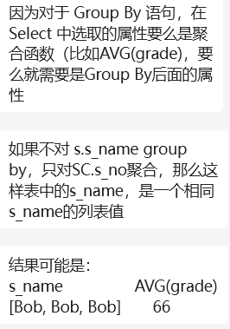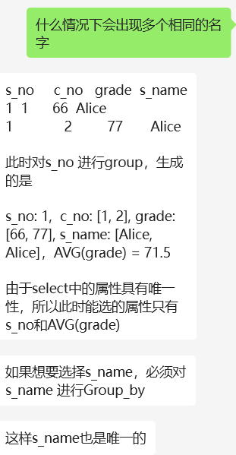

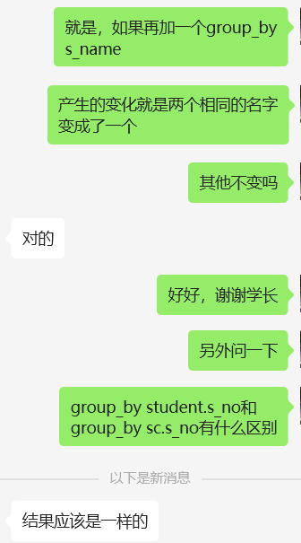

**第*3*题：以下哪些查询是等价的？**

A：Select Count(*)

From T

Where b>100

Group By a

和

Select Count(*)

From T

Group By a

Count(*) 表示您想要计算满足查询条件的行数。

具体地，它将返回表 "T" 中所有满足后续条件的行的总数。

B：Select Count(*)

From T

Where b>100

Group By a

和

Select Count(*)

From T

Group By a

Having AVG(b)>100

C：Select AVG(a)

From T

Where a<10

Group By a

和

Select AVG(a)

From T

Group By a

Having AVG(a)<10 √

D：Select a,AVG(b)

From T

Where b>100

Group By a

这个查询首先会筛选出表 "T" 中满足条件 "b > 100" 的行，然后再按照列 "a" 的值进行分组，最后计算每个分组中列 "b" 的平均值。

这意味着只有那些 "b" 列的值大于 100 的行会被包括在平均值的计算中。

和

Select a,AVG(b)

From T

Group By a

Having AVG(b)>10

这个查询首先会根据列 "a" 的值进行分组，然后计算每个分组中列 "b" 的平均值。接着，使用 HAVING 子句筛选出那些平均值大于 10 的分组。

这意味着在计算平均值之后，只有那些平均值大于 10 的分组会被包括在结果中，但不会限制行的选择。

假设我们有三个关系（同课程中使用的例子一样），其模式分别为

Student(s_no, s_name, birthday, gender)

Course(c_no, c_name, credit)

SC(s_no, c_no, grade)

请写出以下信息需求的SQL查询：

1. 在数学课上成绩超过90分的男生姓名；
2. 数学课成绩超过历史课成绩的女生姓名；
3. 平均成绩超过90分的女生姓名。
4. Select s_name  
   From Student, Course, SC  
   Where Student.s_no = SC.s_no AND SC.c_no = Course.c_no AND c__name = “Math” AND grade > 90 AND gender = “male”
5. Math:  
   Select s_name, SC.s_no, SC.c_no, grade   
   From Student, Course, SC  
   Where Student.s_no = SC.s_no AND SC.c_no = Course.c_no AND c_name = “Math” And gender = “female”  
     
   History:  
   Select s_name, SC.s_no, SC.c_no, grade  
   From Student, Course, SC  
   Where Student.s_no = SC.s_no AND SC.c_no = Course.c_no AND c_name = “History” And gender = “female”  
     
   Select Math.s_name  
   From Math, History  
   Where Math.s_no = History.s_no AND Math.grade > History.grade  
     
   Select s_name

From Student, SC SC_1, SC SC_2, Course C_1, Course C_2

Where Student.gender = “female”

AND C_1.c_name=“Math” AND C_2.c_name=“History”

AND Student.s_no = SC_1.s_no AND Student.s_no = SC_2.s_no

AND SC_1.c_no = C_1.c_no AND SC_2.c_no = C_2.c_no

And SC_1.grade > SC_2.grade

1. Select s_name  
   From Student, SC  
   Where Student.s_no = SC.s_no And gender=”female”  
   Group By SC.s_no, s_name  
   Having AVG(grade) > 90

最好成绩超过平均成绩20分以上的课程名称

Select c_name

From course,sc

Where c_no=sc_no

Having max(grade)-avg(grade)>20

Group by sc.c_no,c_name/group by course.c_no,c_name

共同选了三门以上课程的所有学生组合（学好的两两组合）

Select

s1.s_no AS s_no1,s1.s_name AS s_name1,

s2.s_no AS s_no2,s2.s_name AS s_name2

From student ,students s1,students s2,course, course c1,course c2

Where course

SELECT

s1.s_no AS s_no1,

s2.s_no AS s_no2,

COUNT(*) AS common_course_count

FROM SC s1

JOIN SC s2

ON s1.s_no < s2.s_no AND s1.c_no = s2.c_no

GROUP BY s1.s_no, s2.s_no

HAVING common_course_count >= 3;